PRERNA GAIKWAD

Front End Developer

Contact: **9370611758** Email**: pgaikwad1126@gmail.com**

LinkedIn: [**https://www.linkedin.com/in/prerna-gaikwad-73628a208/**](https://www.linkedin.com/in/prerna-gaikwad-73628a208/%20) e Location: **Aurangabad**

# SUMMARY

As a fresh and enthusiastic Front End Developer, I possess a solid foundation in web development technologies and a passion for creating user-friendly and visually appealing interfaces. With a keen eye for detail and a commitment to delivering high-quality work, I am eager to contribute to projects that blend creativity with functionality.

# EDUCATION

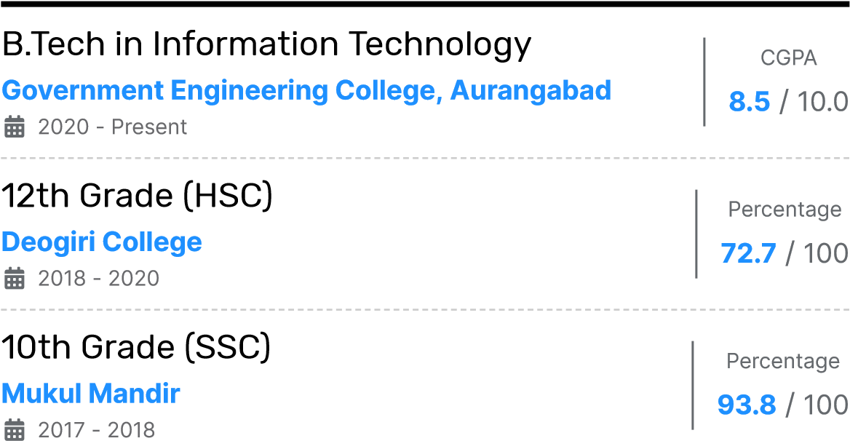

# PROJECTS

## **Personal Portfolio**

My personal portfolio project showcases my skills and accomplishments as a Front End Developer

• Providing a glimpse into my expertise and creativity. Designed with a user centered approach, the portfolio demonstrates my ability to create visually appealing and intuitive interfaces. Through the use of HTML, CSS, and JavaScript, I have developed a responsive and interactive website that highlights my projects, skills, and experience.

# TRAINING / COURSES

**Introduction to Data Science by Infosys Springboard**

**Basics of HTML, CSS by OpenWeaver**

# SKILLS

**HTML**

**CSS**

**JavaScript**

**Java**

**C/C++**

**SQL**

# EXPERIENCE

## Web Developer Intern

**Oasis Infobyte**

Present

Web Development And Services

• I actively contributed to front end development projects, gaining practical experience in building responsive and visually appealing websites.

## Stock Marketing Intern

**Verzeo**

10/2021 - 11/2021

AI Based online learning platform.

• During my internship at Verzeo, I had the opportunity to work on a stock marketing project, where I analyzed market data.

# LANGUAGES

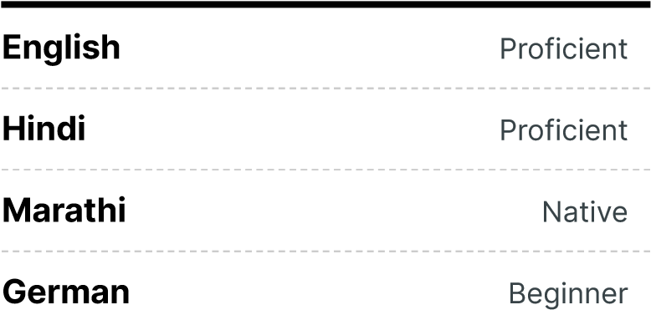

# ACHIEVEMENTS

**Former Writer at TEDxGECA**

Worked as a writer at TEDxGECA 2021.

--------------------------------------------------

## **2nd Rank holder in Group Dance Competition**

As the leader of a group dance team, I had the privilege of leading our collective effort to achieve the second rank in a college level group dance competition.

------------------------------------------------------**Ideathon.3.0**

Participated in Ideathon3.0 organized by AnkurGECA.